Three balls

These balls have been together on a shelf for three days.

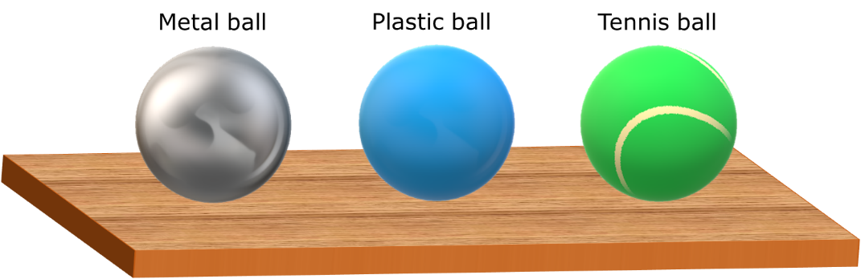

What do you think about the temperature of each ball?
For each statement, tick (✓) one column to show what you think.
Statements |  | I am sure this is right | I think this is right | I think this is wrong | I am sure this is wrong
A | All three balls have the same temperature
B | The metal ball has the lowest temperature
C | The tennis ball has the highest temperature

Physics > Big idea PMA: Matter > Topic PMA1: Heating and cooling > Key concept PMA1.1: Temperature
Diagnostic question
Three balls

Overview
Learning focus: | Temperature is a measure of the average speed at which the particles in a substance or material are moving
Observable learning outcome: | Predict the temperature of different materials that are all in thermal equilibrium with the room
Question type: | Confidence grid
Key words: | Temperature

P | PRIOR UNDERSTANDING  This diagnostic question probes understanding of ideas that are usually taught at age 5-11, to aid transition from earlier stages of learning.

What does the research say?
Students aged 11-12 are often able to use and read a thermometer to take temperature readings, but they often make judgements about the temperature of an object based more on the materials it is made from rather than on the temperature of its surroundings. When a piece of metal and a piece of wood are picked up, both at room temperature, the metal feels colder. This gives some students the belief that they are at different temperatures. It can also lead to the misunderstanding that some materials can be heated and others cannot, which is perhaps reinforced by ideas about thermal conductors and thermal insulators. Most teaching schemes take these ideas for granted. (Erickson and Tiberghien, 1985)
Ways to use this question
Students should complete the confidence grid individually. This could be a pencil and paper exercise, or you could use an electronic ‘voting system’ or mini white boards and the PowerPoint presentation.
If there is a range of answers, you may choose to respond through structured class discussion. Ask one student to explain why they gave the answer they did; ask another student to explain why they agree with them; ask another to explain why they disagree, and so on. This sort of discussion gives students the opportunity to explore their thinking and for you to really understand their learning needs.
Differentiation
You may choose to read the questions to the class, so that everyone can focus on the science. In some situations it may be more appropriate for a teaching assistant to read for one or two students.

Equipment
For the class:
- A metal ball, a plastic ball and a tennis ball and an infra-red thermometer (Optional)
Expected answers
A: All three balls have the same temperature is correct and the other answers are wrong.
How to respond - what next?
The balls are each at the same temperature as their surroundings because they have had sufficient time to reach a thermal equilibrium.
The metal ball feels cold to touch and some students may attribute this to it being at a lower temperature. The reason it feels colder is a challenging idea that is considered in the BEST key concept: PMA1.2 Heating and cooling. (Energy is conducted away from the thermal store of the hand quickly by the metal.)
Students who do not think that all the balls are each at the same temperature may be unsure as to whether the tennis ball or the plastic ball has the highest temperature. This may be because they are not sure which one feels the warmest.
If students have misunderstandings about whether the balls are each at the same temperature, it can help to demonstrate that balls of different materials that are in thermal equilibrium all have the same temperature, by measuring their temperatures with an infra-red thermometer. The following BEST ‘response activity’ is a student practical that could be used in follow-up to this diagnostic question:
- Response activity: Water and sand
Acknowledgments
Developed by Peter Fairhurst (UYSEG).
Images: Peter Fairhurst (UYSEG).
References
Erickson, G. and Tiberghien, A. (1985). Heat and Temperature. In Driver, R., Guesne, E. & Tiberghien, A. (eds.) Children's Ideas In Science. Milton Keynes and Philadelphia: Open University Press.

